Andrew Sosanya

Dartmouth College

Caltech Wave Fellow

Physics, Mathematics, and Astronomy Department

*Mentors: Fiona A. Harrison and Murray Brightman*

**“Searching for neutron-star-powered ultraluminous X-ray sources and measuring their magnetic field strengths”**

Our high-energy astrophysics group studies energetic phenomena ranging from gamma-ray bursts, black holes on all mass scales, to neutron stars, supernovae remnants and collapsed stars. We are especially interested in X-ray sources in numerous galaxies.

**Project Description**

Ultraluminous X-ray sources (ULXs) are variable, non-nuclear bright X-ray sources in nearby galaxies not associated with the central supermassive black hole. These ULXs are brighter than black hole systems in our galaxy––these sources show pulsations. They have super-Eddington luminosities the accretion limit of a black hole of 10 solar masses. The Eddington luminosity limit of a star is the maximum luminosity a star can achieve due to the hydrostatic equillibrium between the force of radiation acting outward and the gravitational force acting inward. This constraint on radiation from the star limits its accretion flow. These ULXs break the Eddington theory because there are extreme accretion rates onto a compact stellar remnant, or an intermediate mass black hole. The discovery of X-ray pulsations suggests that these ULXs may be powered by accretion from magnetized neutron stars (Bachetti et al. 2014). Bachetti et al also found that these neutron stars may not be rare within ULXs. The distinguishing factors between neutron star-powered ULXs and intermediate-mass (∼100−105 M⊙) black hole powered ULXs remains uncertain, as the luminosities of ULXs can imply either as a cause. The neutron star surface field is very high, on the order of 1014G, which suppresses the electron scattering cross section that reduces the accretion rate for high luminosities. We seek to find signatures magnetic fields through cyclotron resonance scattering features (CRSFs) in ULX-abundant galaxies. These CSRFs are more likely to be found in absorption rather than emission[1].

**Progress**

**Methods**

In the last report, scripts were created to cross-reference a catalogue of XMM telescope observations to find 10,000+ count ULXs and using the spectral fitting software XSPEC v12.9 and pre-reduced data from past observations, we systematically searched for CSRFs. The search narrowed down to four neutron-star powered candidates: NGC 1313, Holmberg II X-1, M32, and IC-342. To further investigate these ULXs, we used XMM’s Spectral Analysis System (SAS), turned to raw data reduction to analyze further their characteristics. We corrected for background flaring with a photon rate cutoff of 0.4 photons . Later we varied the photon rate cutoff to get more counts. We tested patterns 0 and 1-4 to account for X-ray events that are split between pixels. Using the astronomical imaging software DS9, we selected our centroid, and picked a uniform background region to serve as a baseline background spectra for our reduction. We then normalized that spectra via the BACKSCAL value which is computed as:

Lastly, we created the response and auxiliary matrix files and then grouped the spectrum.

The systematic search through our newly reduced data was similar to the search through pre-reduced data. We fit within the 2.0-10.0 keV energy range using several models: an absorbed power-law model with a high-power cutoff, contour plot, the Tuebingen-Boulder ISM absorption model, and a Gaussian absorption model. Goodness-of-fit was determined with the chi-squared statistic generally around 10 and larger. Power-law index was set to with norm ~1E-4. We switched had three varied parameters for our tests: the energy at which we predicted CSRFs [5, 6, 7 keV]; the Gaussian width of those CRSFs [0.1, 0.3 keV]; the detector radius, which could increase incoming flux counts, but could potentially compromise the signal-to-noise ratio [30, 40, 50, 60].

**Results**

In the last report, we erroneously stated that there were only two promising candidates: Holmberg II and IC-342. However, an off-by-one error brought to light two more sources: NGC 221 (also known as M32) and NGC 1313. Holmberg II and M32 observations were reduced. So far.

Holmberg II’s promising ~ 11 led to a disappointment in data reduction results.

We checked for CSRFs in observations 0112520701 and 0200470101, and neither undoubtedly resulted in statistically significant s. For 0112520701, counts and values were low due to intense background flaring. We increased counts by increasing the photon rate cutoff but signal-to-noise ratio decreased and values were still low. 0200470101 had more reasonable characteristics, but nothing significant to show. Tests will be redone to confirm findings.

[insert plots, and tables]

M32’s analysis has not started on either XMM or Chandra.

-Insert IC 342 test plots…. –

**Looking Forward**

We’ve run into numerous problems such as intense background flaring, data reduction techniques, and catalogue inconsistencies. Software handling and timeliness of data reduction has also caused some delays.

Observation 0112520701 for Holmberg II was charred by the intense background flaring during the observation. It is unclear why an observation would appear in the XMM-Newton Serendipitous Source Catalog (3XMM DR8 Version) with listed characteristics of a high-count X-ray source. More investigation is needed, but for now that observation cannot be used.

A further investigation of M32 will take place. However, there are three distinct X-ray sources in the observations, with one source dominating the others. XMM does not have enough of a resolution to collect sufficient data for M32’s ULXs. Therefore, we need to perform an analysis with Chandra data because Chandra has a higher resolution in the 0.2-10 keV energy band.

With the dearth of successful results in Holmberg X-1—but success of partly automating the reduction process, we have decided to also consider IC 342, one of our other neutron star ULX candidates alongside M32. IC 342 had an intensity of 13887 counts in observation 0206890201 and 29441 counts in observation 0206890101.

Additionally, there is the potential appearance of atomic absorption lines that could be mistaken CRSFs. These make for dubious cases of data analysis. For example, Walton et al. found an Iron K component absorption feature at E = 8.77+/0.05 keV in NGC 1313 X-1, a neutron star candidate.

Potential errors in the data were discovered shortly before submitting this report. I had an off-by-one error within the scripts that propagated error within the data. Luckily, the the two sources shown above were still valid. The error was found, and the new analysis was verified.

In addition to this project, I have been working on NuDetect, a software and hardware collaboration consisting of NuStar engineer Hiromasa Miyasaka, graduate student Sean Pike, and SURF student Julian Sander. We are testing new x-ray detectors for the NuStar Telescope. We write software to test for electronic noise, leakage current and inter-pixel conductivity within the detector apparatus to filter for the most ideal detector.

Links to scripts:

* NuStar ULX Analysis Github: <https://github.com/DrewSosa/NuStar>
* Github: <https://github.com/cyangiraffe/nudetector>

**References**

**An Iron K Component to the Ultrafast Outflow in NGC 1313 X-1**

Walton, D. J., M. J. Middleton, C. Pinto, A. C. Fabian, M. Bachetti, D. Barret, M. Brightman, et al.

*The Astrophysical Journal* 826, no. 2 (July 29, 2016): L26.

**Cyclotron resonant scattering feature simulations. II. Description of the CRSF simulation process**   
F. -W. Schwarm*et al.*. 11 pp.   
Published in Astron.Astrophys. 601 (2017) Jan 26, 2017 A99

**Magnetic field strength of a neutron-star-powered ultraluminous X-ray source**

M. Brightman et al.

Nature Astronomy; Vol 2. April 2018

**An ultraluminous X-ray source powered by an accreting neutron star**

Bachetti et al. Nature; London Vol. 514, Iss. 7521, (Oct 9, 2014): 202-4.

**New Observations of the Cyclotron Absorption Feature in Her X-1.**

Mihara, T.

*Nature*, n.d. Vol. 346 19 July 1990.

**Soft extragalactic X-ray binaries at the Eddington Threshold.**

Earnshaw H.M and Roberts T.P. Mon. Not. R.

Astron. Soc., 467, 2690-2705 3 May 2017

Figures

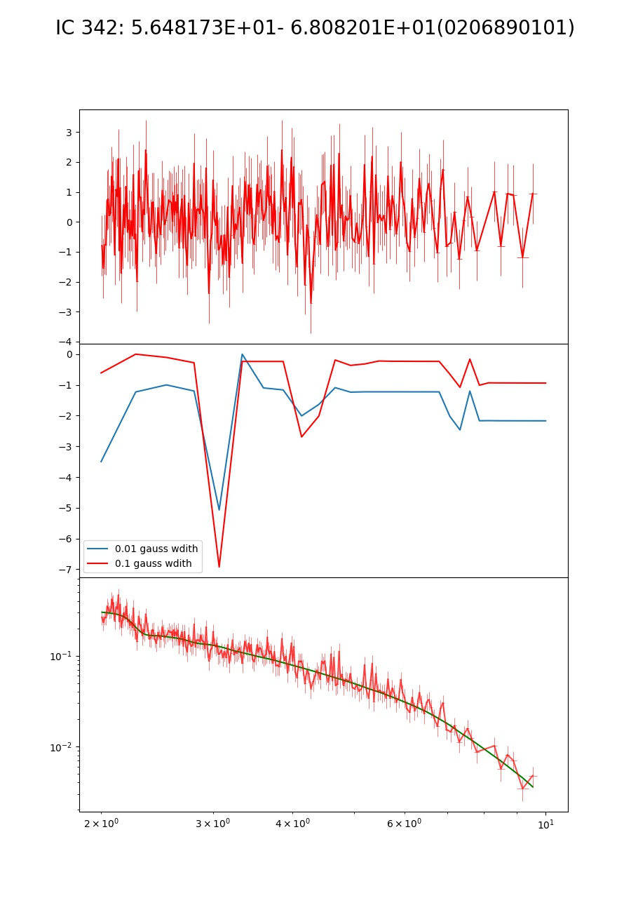

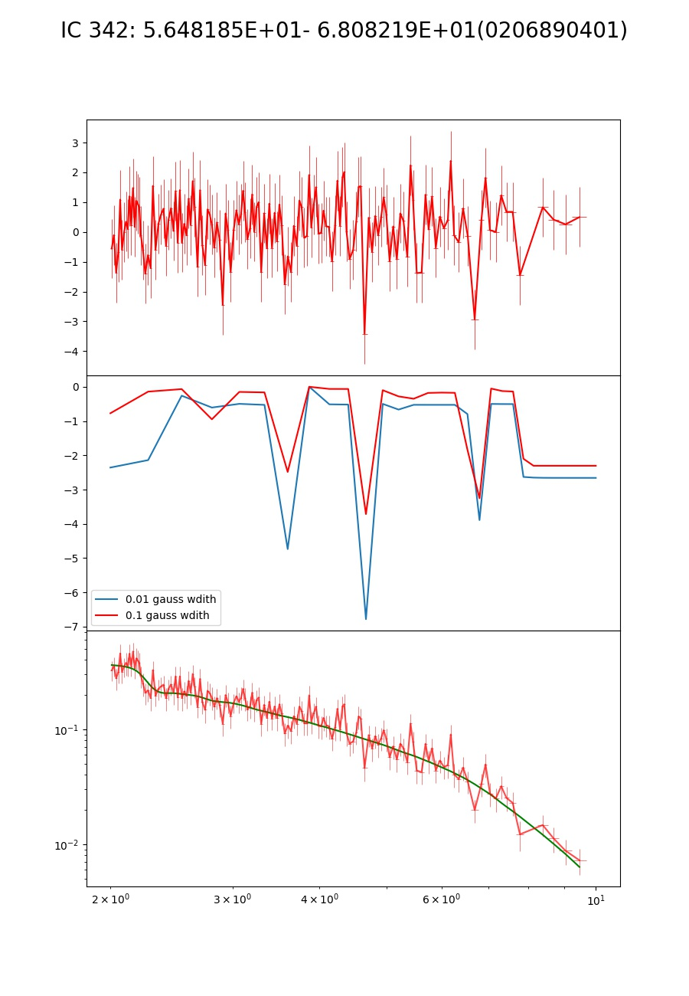

1. Mihara et al.